BACKYARD CHICKEN LOCATION / PROPERTY OWNER & APPLICANT INFORMATION
1 | Backyard Chicken Location- (street, City, State, Zip): Click or tap here to enter text.
1 | Municipality: Click or tap here to enter text. |  |  | Lot Size (acres / ft²)  Click or tap here to enter text. |  | Parcel ID # Click or tap here to enter text.
1 | PLEASE NOTE: If a project is located either entirely or partially within a SFHA, additional supplemental applications and documents will be required. To determine whether your property is designated as SFHA contact the Warren County Zoning Officer/ Floodplain Administrator or visit https://msc.fema.gov/portal/home
2 | Name of Applicant: Click or tap here to enter text. |  |  |  |  | Phone: Click or tap here to enter text.
2 | Mailing Address: Click or tap here to enter text. |  |  |  |  |  | City: Click or tap here to enter text.
2 | State:  Click or tap here to enter text. |  | Zip Code:  Click or tap here to enter text. |  | Email Address: Click or tap here to enter text.
3 | Name of Property Owner(s): Click or tap here to enter text.  ☐ Same as Applicant |  |  |  |  | Phone: Click or tap here to enter text.
3 | Mailing Address: Click or tap here to enter text. |  |  |  |  |  |  | City: Click or tap here to enter text.
3 | State:  Click or tap here to enter text. | Zip Code: Click or tap here to enter text. |  |  | Email Address: Click or tap here to enter text.

5 | PROPOSED PROJECT: TYPE OF WORK
5 | Check the boxes that apply:  ☐ Constructing new chicken coop ☐ Existing structure to become chicken coop (Change of Use permit also required)  ☐ Chicken Coop will be an addition to existing structure ☐ Other (if the type is not listed, briefly describe:
5 | Are you renting or leasing the property? ☐ Yes ☐ No | Was the property owner notified of the proposed project? ☐ Yes ☐ No  (Landowner authorization is required)
5 | Will the issuance of this permit application resolve an open violation? ☐ Yes ☐ No
5 | Briefly describe the proposed project and construction details: Click or tap here to enter text.

6 | PROPOSED STRUCTURE DETAILS
6 | Chicken Coop  Dimensions | Length  Click or tap here to enter text. | Width  Click or tap here to enter text. |  | Height  Click or tap here to enter text. | Total Sqft  Click or tap here to enter text.
6 | Outside Run Dimensions | Length  Click or tap here to enter text. | Width  Click or tap here to enter text. |  | Height  Click or tap here to enter text. | Total Sqft  Click or tap here to enter text.
6 | Quantity of Chickens proposed to be on the parcel:  Click or tap here to enter text.
6 | Construction Start Date: Click or tap to enter a date. |  |  | Construction Completion Date: Click or tap to enter a date.

7 | PROPOSED SETBACK DISTANCES
7 | Provide the closest distance from the proposed structure or addition to the nearest property line or right-of-way (ROW).  No portion of any structure, the building foundation or wall, may extend nearer to the property line or ROW than required by the setback depth:  Note: A setback requirement is the minimum allowable distance your structure can be from a given property line. Setback requirements vary depending on your zoning district, the type of road your property is on, and other factors. If you are unsure about the required setbacks for your project, please contact the zoning officer for guidance before submitting your application. *Corner lot properties have two front yards (one along each street frontage) and two side yards (no rear yard)
  Front Setback (ft): | Side (Front*) Setback (ft):  Click or tap here to enter text.
  Rear (Side*) Setback (ft):  Click or tap here to enter text.  Click or tap here to enter text. | Side Setback (ft):  Click or tap here to enter text.

Permit # | FOR OFFICE USE ONLY |  |  | Date Filed:
Parcel/Tax ID: |  |  |  | Zoning District:
Plot Plan ________________ SWM Plan ___________________ Sewage Permit # ______________________ issued on _____/______/______
FEE: $ ___________ ☐ CASH ☐ CHECK _____________ ☐ CC___________________________________________ DATE REC’D______/_______/______
FLOOD ZONE: __________ ☐ FLOODWAY FLOOD MAP PANEL # _________________________________ MAP DATE ______/_______/______
☐ Requires Variance, Special Exception or Conditional Use ☐ Approved ☐ Denied on _____________________ ZHB Permit #:
ZONING PERMIT: ☐ APPROVED ☐ DENIED on ______/_______/_____ by ____________________________________________________________
Notes:

☐ Building Permit |  | ☐ Floodplain Development | Violation#: ______________ ☐ N/A

.

PLEASE READ THE FOLLOWING REQUIREMENTS CAREFULLY AND INITIAL EACH TO SHOW YOU HAVE READ AND UNDERSTAND THE BACKYARD CHICKEN ORDINANCE IN ITS ENTIRETY.
8
_____ I have read the Warren County Zoning Ordinance Section 401.50 and understand the requirements for keeping chickens.
_____ I am aware that I first must apply and receive approval from the Warren County Planning and Zoning Office prior to obtaining chickens.
_____ I will follow all County, Municipal, and State laws relating to the care of and keeping animals.
_____ I understand that I am responsible for keeping chickens within the enclosed coop / outside run at all times. During night time hours, the chickens shall be restricted to the enclosed coop.
_____ I understand that I may not make any dimensional changes (affecting required property set-backs or minimum space requirements) to my chicken coop without first obtaining approval from the Zoning Office.
_____ I understand the maximum number of chickens allowed in relation to my parcel size as detailed in Section 401.50 and agree not to exceed allowable number of chickens as listed on this application.
_____ I understand Roosters are not permitted
_____ I understand the sale of chickens, eggs and/or byproducts is not permitted
_____ I acknowledge that I live in a single-family dwelling as per zoning code and if I rent, I have approval from my landlord (see and complete attachment).
_____ I understand that the permit is not transferrable from one individual or location to another.
_____ I understand the private restrictions on the use of the property shall remain enforceable and shall supersede the permit. I affirm that there are no private restrictions including, but not limited to, deed restrictions, condominium restrictions, neighborhood association bylaws, covenants, restrictions, and rental agreements. A permit issued to a person whose property is subject to private restrictions that prohibit keeping chickens is void.
_____ I acknowledge that I am aware that the ordinance allowing chickens may be amended or repealed and that the owner acquires no vested rights to have or raise chickens by virtue of the issuance of the permit.
_____ I understand that the keeping and handling of chickens may cause health hazards and that adequate health precautions are the responsibility of the applicant.
_____ I understand abandoned chicken coops shall be removed from property if unused for a period of 12 months

Understandings & Agreements
9
Acknowledgement of Requirements
I, the undersigned, hereby authorize Warren County Planning & Zoning to communicate with me and/or my designated representative via electronic mail (email) for all matters relating to this permit application, including but not limited to notifications, requests for additional
information, determinations, and final decisions.
Signature:
Printed Name:
☐ I do not have an email address and wish to communicate by telephone and/or mail.

I hereby confirm that I have the legal authority to grant this authorization and certify that the information provided in this application, as well as any attached documents, is true and accurate to the best of my knowledge. The applicant understands and agrees that any errors, misstatements, or misrepresentations of material facts, whether intentional or not, may result in the denial of this application.

Additionally, any changes in the location, size, or use of the structure or land after the issuance of this permit, without prior approval from the Zoning Officer or Zoning Hearing Board (ZHB), will be grounds for revocation of this permit.

The applicant agrees to permit the Zoning Officer or an appointed assistant to inspect all structures and land related to this application. Once construction is complete, the applicant agrees to contact the Zoning Officer to schedule the necessary final inspections on-site.
☐ Owner ☐ Applicant ☐ Authorized Representative
Signature:
Printed Name: | Date:

LANDLORD AUTHORIZATION (to be completed if placing chickens on leased / rented property)
I am the owner / landlord of _______________________________________and I grant permission for my tenant,
________________________________________, to install a chicken coop / outside run and keep chickens on the property. I acknowledge that as owner / landlord of the property identified in this application that I accept responsibility for compliance with Section 401.50 related to keeping chickens should the tenant move from the property and/or neglect to maintain compliance with Section 401.50 in its entirety.
______________________________________ ______________________________ ______________
Landlord / Owner Signature Contact Telephone Number Date

10 | INFORMATION
10 | APPROVED STORMWATER MANAGEMENT PLAN
10 | In every municipality, a stormwater management plan (SWM) is required whenever 2,500 square feet or more of impervious surface is proposed. Impervious surfaces are areas that prevent the infiltration of water into the ground and shall include, but not be limited to, roofs, patios, garages, storage sheds, similar structures, gravel & paved driveways, and any new streets or sidewalks. Certain municipalities require the applicant to submit a SWM for all projects, regardless of size. Check with your municipality or zoning officer to determine whether a SWM plan is required.
10 | SURVEY
10 | The zoning officer may require a survey map if the submitted plans are insufficient to confirm compliance or when accurate property boundary information cannot be verified.
10 | The applicant is required to submit a plot plan of the property showing property lines, existing structures (buildings, driveway, pools, fences), and proposed new structure, additions, or changes. This acts as a bird’s-eye map, illustrating the layout and features of a parcel of land to verify everything fits within the legal boundaries. The Zoning Officer can provide an aerial view of the parcel upon request. An example and additional instructions are provided in section 15 of this application.
  PLOT PLAN
10 | FEE
10 | The applicable zoning permit fee is required to be submitted with the zoning permit application. See section 14 of this application to review the fee schedule. (Fees are subject to change)
10 | FLOODPLAIN DEVELOPMENT
10 | For development either entirely or partially within a Special Flood Hazard Area, the applicant may need to complete the Supplemental Floodplain Development Permit Application. Projects located in the floodplain may require additional review, documentation, and coordination with qualified professionals, which can increase both project timelines and costs.
10 | BUILDING PERMIT
10 | In addition to the Zoning Permit, a Building Permit may also be required for your project. While the zoning permit confirms your project is in compliance with local land-use rules (what you can build, where you can build and how it can be used), the building permit ensures the actual construction meets safety and code standards (how you build it).
10 | ZONING HEARING BOARD (ZHB)
10 | Depending on the project, approval from the Zoning Hearing Board may be required before a zoning permit can be issued by the zoning officer. Pursuant to Article VIII Section 808 of the Warren County Zoning Ordinance, the Zoning Hearing Board has several functions, including, but not limited to, making decisions on application requests for Variances and Special Exceptions and Appeals from the determination of the Zoning Officer. A $450 fee is required to apply to the Zoning Hearing Board.
11 | When is an application considered complete?
11 | An application is complete when all required documents and fees have been received by the zoning officer.  That may include, but is not limited to, a signed and completed zoning permit application, plot plan and/or survey, zoning permit fee, a sewage permit, a SWM plan, and, in some cases, approval from the Zoning Hearing Board.
12 | When would a zoning permit application be denied? What can I do?
12 | Several factors could result in the denial of a zoning permit application, such as non-compliance with the Warren County Zoning Ordinance (i.e, prohibited use, dimensional violations, insufficient services) and incomplete or inaccurate documentation.  Pursuant to Section 808 of the Warren County Zoning Ordinance, any person aggrieved by any action or decision of the zoning officer concerning the administration of the provisions of the Warren County Ordinance may appeal to the Zoning Hearing Board. Such an appeal must be filed, in writing, within 30 days after the decision or action of the zoning officer. The completed appeal application and fee must be submitted to the Planning & Zoning Office within that timeframe. There is a $450 filing fee due at the time the application is submitted. A public hearing would be scheduled within 60 days. Notice of the time and place of the hearing would be given to all parties.
13 | WARREN COUNTY ZONING ORDINANCE
13 | The Warren County Zoning Ordinance can be can be viewed on the County’s website.  https://www.warrencountypa.gov/1197/Planning-Zoning

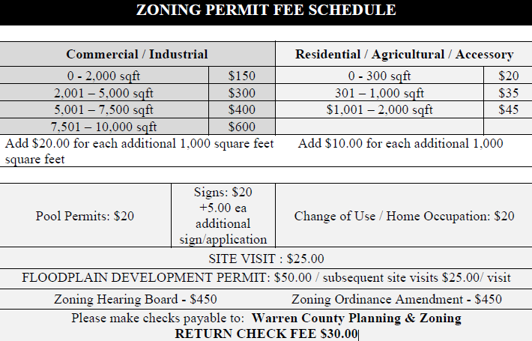
14

Please note: Zoning Permits will be issued via email; Hard Copies are available upon request.

The Plot Plan MUST include:
• All current structures located on the property: Home, garage, shed, pools, etc.
• All property lines
• Location & dimensions of ALL proposed structures
• ALL SETBACKS (distances from new structures to the nearest property line or right-of-way)
• All Street/Road Names / Locations
• All Streams, Rivers, Drainage Ditches, etc.
• All rights-of-way or easements
• All locations of on-lot septic systems or municipal sewer connections
**The plot plan does not have to be to scale.

SAMPLE PLOT PLAN & INSTRUCTIONS
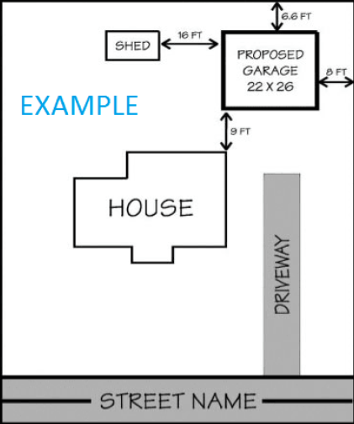
15

