PROJECT LOCATION / PROPERTY OWNER & APPLICANT INFORMATION
1 | Project Location- (street, City, State, Zip): Click or tap here to enter text.
1 | Municipality: Click or tap here to enter text. |  | Lot Size (acres / ft²):  Click or tap here to enter text. |  | Parcel ID # Click or tap here to enter text.
2 | Name of Applicant: Click or tap here to enter text. |  |  |  | Phone: Click or tap here to enter text.
2 | Mailing Address: Click or tap here to enter text. |  |  |  |  | City: Click or tap here to enter text.
2 | State:  Click or tap here to enter text. | Zip Code:  Click or tap here to enter text. |  | Email Address: Click or tap here to enter text.
3 | Name of Property Owner(s): Click or tap here to enter text.  ☐ Same as Applicant |  |  |  | Phone: Click or tap here to enter text.
3 | Mailing Address: Click or tap here to enter text. |  |  |  |  |  | City: Click or tap here to enter text.
3 | State:  Click or tap here to enter text. | Zip Code:  Click or tap here to enter text. |  | Email Address: Click or tap here to enter text.
4 | Name of Contractor/Builder: Click or tap here to enter text. |  |  |  | Phone: Click or tap here to enter text.
4 | Email Address: Click or tap here to enter text.

5 | PROPOSED PROJECT: TYPE OF WORK
5 | Describe the proposed sign(s) and its intended purpose:  Click or tap here to enter text.
5 | Check each box that best describes the type of sign to be erected: ☐ Sign ☐ Wall Sign ☐ Pole Sign ☐ Ground Sign  ☐ Temporary promotional device, sign, banner, display ☐ Directional ground sign ☐ multi-tenant identification sign (Shopping Center) ☐ Outdoor Advertising Device (Billboard) ☐ Other (describe):
5 | The sign is:  ☐ illuminated ☐ non-illuminated | The sign(s) will be: ☐ on-premise: describe location: _______________  Click or tap here to enter text.  Click or tap here to enter text.  ☐ off-premise: ______ miles from the establishment
5 | Will the sign be located on a designated scenic or other byway (i.e., Route 59, Route 6) ☐ Yes ☐ No  Click or tap here to enter text.
5 | Will the issuance of this permit application resolve an open violation? ☐ Yes ☐ No

6 | PROPOSED SIGN DETAILS (1)
6 | SIGN  DIMENSIONS | Length of sign face: | Height of sign face:  Click or tap here to enter text. |  | Depth:  Click or tap here to enter text. |  | Total Sqft (Sign Face only):
6 | SIGN  DIMENSIONS | Height from the ground to top of sign when erected:  Click or tap here to enter text. |  |  |  | Height from the ground to the bottom of sign face when erected:  Click or tap here to enter text.
6 | What material is being used to construct the sign?  Click or tap here to enter text.
6 | Total linear feet of horizonal building façade (for wall signs):  Click or tap here to enter text.
6 | Will the placement of the sign interfere with the required free sight triangle (see Section 507.3.5.2) or pedestrian or traffic visibility? ☐ YES ☐ NO
6 | For wall signs; how far will the sign project from the building façade to which it is attached?
6 | Will the sign be placed on the roof or extend above the height of the building? ☐ placed on the roof ☐ sign will extend above building height ☐ N/A
6 | Construction Start Date: Click or tap to enter a date. |  |  | Construction Completion Date: Click or tap to enter a date.

7 | EXISTING SIGNS
7 | List the total square feet, location and purpose off each sign currently on and off the property:  Click or tap here to enter text.  Click or tap here to enter text.

For the application of multiple signs, please complete pages 1 & 2, for each sign, and submit along with page 3.
The first sign is $20. Each additional sign/application is $5.

Understandings & Agreements
8
Acknowledgement of Requirements
I, the undersigned, hereby authorize Warren County Planning & Zoning to communicate with me and/or my designated representative via electronic mail (email) for all matters relating to this permit application, including but not limited to notifications, requests for additional
information, determinations, and final decisions.
Signature:
Printed Name: Click or tap here to enter text.
☐ I do not have an email address and wish to communicate by telephone and/or mail.

I hereby confirm that I have the legal authority to grant this authorization and certify that the information provided in this application, as well as any attached documents, is true and accurate to the best of my knowledge. The applicant understands and agrees that any errors, misstatements, or misrepresentations of material facts, whether intentional or not, may result in the denial of this application.

Additionally, any changes in the location, size, or use of the structure or land after the issuance of this permit, without prior approval from the Zoning Officer or Zoning Hearing Board (ZHB), will be grounds for revocation of this permit.

The applicant agrees to permit the Zoning Officer or an appointed assistant to inspect all structures and land related to this application. Once construction is complete, the applicant agrees to contact the Zoning Officer to schedule the necessary final inspections on-site.
☐ Owner ☐ Applicant ☐ Authorized Representative
Signature:

Permit # | FOR OFFICE USE ONLY |  |  | Date Filed:
Parcel/Tax ID: |  |  |  | Zoning District:
Plot Plan ________________ SWM Plan ___________________ Sewage Permit # ______________________ issued on ___________________________
FEE: $ ____________ ☐ CASH ☐ CHECK _____________ ☐ CC___________________________________________ DATE REC’D ____________________________

Flood Zone: __________ ☐ Floodway Flood Map Panel # _________________________________ Map Date ____________________________
☐ Requires Variance, Special Exception or Conditional Use ☐ Approved ☐ Denied on _____________________ ZHB Permit #:
ZONING PERMIT: ☐ APPROVED ☐ DENIED on ______/_______/_____ by ____________________________________________________________
Notes:

☐ Building Permit |  | ☐ Floodplain Development | Violation#: ______________ ☐ N/A

9 | INFORMATION
9 | APPROVED STORMWATER MANAGEMENT PLAN
9 | In every municipality, a stormwater management plan (SWM) is required whenever 2,500 square feet or more of impervious surface is proposed. Impervious surfaces are areas that prevent the infiltration of water into the ground and shall include, but not be limited to, roofs, patios, garages, storage sheds, similar structures, gravel & paved driveways, and any new streets or sidewalks. Certain municipalities require the applicant to submit a SWM for all projects, regardless of size. Check with your municipality or zoning officer to determine whether a SWM plan is required.
9 | SURVEY
9 | The zoning officer may require a survey map if the submitted plans are insufficient to confirm compliance or when accurate property boundary information cannot be verified.
9 | The applicant is required to submit a plot plan of the property showing property lines, existing structures (buildings, driveway, pools, fences), and proposed new structure, additions, or changes. This acts as a bird’s-eye map, illustrating the layout and features of a parcel of land to verify everything fits within the legal boundaries. The Zoning Officer can provide an aerial view of the parcel upon request. An example and additional instructions are provided in section 11 of this application.
  PLOT PLAN
9 | FEE
9 | The applicable zoning permit fee is required to be submitted with the zoning permit application. See section 10 of this application to review the fee schedule. (Fees are subject to change)
9 | FLOODPLAIN DEVELOPMENT
9 | For development either entirely or partially within a Special Flood Hazard Area, the applicant may need to complete the Supplemental Floodplain Development Permit Application. Projects located in the floodplain may require additional review, documentation, and coordination with qualified professionals, which can increase both project timelines and costs.
9 | BUILDING PERMIT
9 | In addition to the Zoning Permit, a Building Permit may also be required for your project. While the zoning permit confirms your project is in compliance with local land-use rules (what you can build, where you can build and how it can be used), the building permit ensures the actual construction meets safety and code standards (how you build it).
9 | ZONING HEARING BOARD (ZHB)
9 | Depending on the project, approval from the Zoning Hearing Board may be required before a zoning permit can be issued by the zoning officer. Pursuant to Article VIII Section 808 of the Warren County Zoning Ordinance, the Zoning Hearing Board has several functions, including, but not limited to, making decisions on application requests for Variances and Special Exceptions and Appeals from the determination of the Zoning Officer. A $450 fee is required to apply to the Zoning Hearing Board.
9 | When is an application considered complete?
9 | An application is complete when all required documents and fees have been received by the zoning officer.  That may include, but is not limited to, a signed and completed zoning permit application, plot plan and/or survey, zoning permit fee, a sewage permit, a SWM plan, and, in some cases, approval from the Zoning Hearing Board.
9 | When would a zoning permit application be denied? What can I do?
9 | Several factors could result in the denial of a zoning permit application, such as non-compliance with the Warren County Zoning Ordinance (i.e, prohibited use, dimensional violations, insufficient services) and incomplete or inaccurate documentation. Pursuant to Section 808 of the Warren County Zoning Ordinance, any person aggrieved by any action or decision of the zoning officer concerning the administration of the provisions of the Warren County Ordinance may appeal to the Zoning Hearing Board. Such an appeal must be filed, in writing, within 30 days after the decision or action of the zoning officer. The completed appeal application and fee must be submitted to the Planning & Zoning Office within that timeframe. There is a $450 filing fee due at the time the application is submitted. A public hearing would be scheduled within 60 days. Notice of the time and place of the hearing would be given to all parties.
9 | WARREN COUNTY ZONING ORDINANCE
9 | The Warren County Zoning Ordinance can be can be viewed on the County’s website.  https://www.warrencountypa.gov/1197/Planning-Zoning

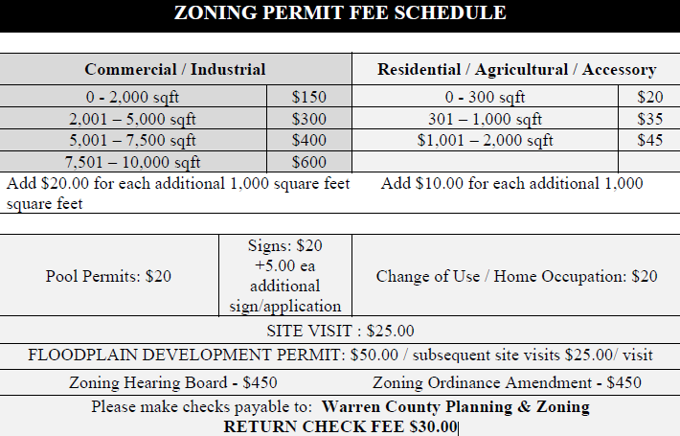
10

Please note: Zoning Permits will be issued via email; Hard Copies are available upon request.

The Site Plan MUST include:
• All current structures located on the property: Home, garage, shed, pools, etc.
• All property lines
• Location & dimensions of ALL proposed structures
• ALL SETBACKS (distances from new structures to the nearest property line or right-of-way)
• All Street/Road Names / Locations
• All Streams, Rivers, Drainage Ditches, etc.
• All rights-of-way or easements
• All locations of on-lot septic systems or municipal sewer connections
**The plot plan does not have to be to scale.

SAMPLE PLOT PLAN & INSTRUCTIONS
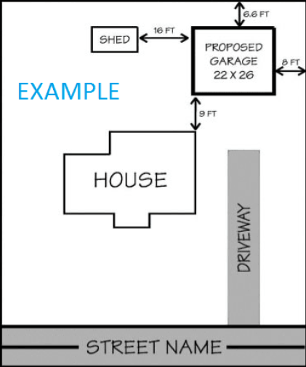
11

